UNIT-III
SEARCH TREES

Tree
A Tree consists of a finite set of elements, called nodes, and set of directed lines called branches, that connect the nodes.
The no. of branches associated with a node is the degree of the node.
i.e. in - degree and out - degree.

- A leaf is any node with an out degree of zero. i.e. no successor
- A node that is not a root or leaf is known as an internal node
- A node is a parent if it has successor node, conversely a node with a predecessor is called child
- A path is a sequence of nodes in which each node is adjacent to the next one
- The level of a node is its distance from the root
- The height of the tree is the level of the leaf in the longest path from the root plus 1
- A sub tree is any connected structure below the root. Sub tree can also be further divided into sub trees

Binary tree:
A binary tree is a tree in which no node can have more than two sub trees designated as the left sub tree and the right sub tree.
Note: each sub tree is itself a binary tree.

Balance factor:
The balance factor of a binary tree is the difference in height between its left and right sub trees. i.e. Balance factor = H_{L} - H_{R}

In a balanced binary tree, the height of its sub trees differs by no more than one (its balance factor is -1, 0, +1) and also its sub trees are also balanced.
We now turn our attention to operations: search, insertion, deletion
In the design of the linear list structure, we had two choices: an array or a linked list

- The array structure provides a very efficient search algorithm, but its insertion and deletion algorithm are very inefficient.
- The linked list structure provides efficient insertion and deletion, but its search algorithm is very inefficient.

What we need is a structure that provides an efficient search, at the same time efficient insertion and deletion algorithms.
The binary search tree and the AVL tree provide that structure.

Binary search tree:
A binary search tree (BST) is a binary tree with the following properties:
- All items in the left sub tree are less than the root.
- All items in the right sub tree are greater than or equal to the root.
- Each sub tree is itself a binary search tree.

While the binary search tree is simple and easy to understand, it has one major problem:
It is not balance.

To over come this problem, AVL trees are designed, which are balanced.

AVL TREES
In 1962, two Russian mathematicians, G.M Adelson – velskii and E.M Landis, aerated the balanced binary tree structure that is named after them – the AVL tree.

An AVL tree is a search tree in which the heights of the sub trees differ by no more than 1. It is thus a balanced binary tree.

An AVL tree is a binary tree that either is empty or consists of two AVL sub tree, T_{L} and T_{R}, whose heights differ by no more than 1.

| H_{L} - H_{R} | < = 1
Where H_{L} is the height of the left sub tree, H_{R} is the height of the right sub tree
The bar symbols indicate absolute value.

NOTE: An AVL tree is a height balanced binary search tree.

Consider an example: AVL tree
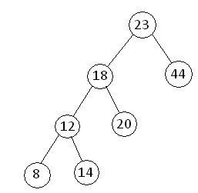

AVL Tree Balance factor:
The Balance factor for any node in an AVL tree must be +1, 0, -1.

We use the descriptive identifiers
- LH for left high (+1) to indicate that the length sub tree is higher than the right sub tree
- EH for even high (0) to indicate that the sub tree are the same height
- RH for right high (-1) to indicate that the left sub tree is shortest than the right sub tree

Balancing Trees:
When ever we insert a node into a tree or delete a node from a tree, the resulting tree may be unbalanced then we must rebalance it.

AVL trees are balanced by rotating nodes either to the left or to the right.

Rotations:
Rotations are mechanisms which shift some of the sub trees of the unbalanced tree either to left or right to obtain a balanced tree.
There are four rotations and they are classified into two types.
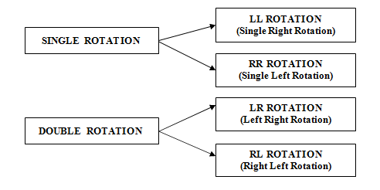

LL Rotation (Single Right Rotation)
- The new node ‘x’ is inserted in the Left sub tree of left child of node A. As a result, the balance of A becomes +2.
- To restore balance at A Single right rotation need to be applied at A.

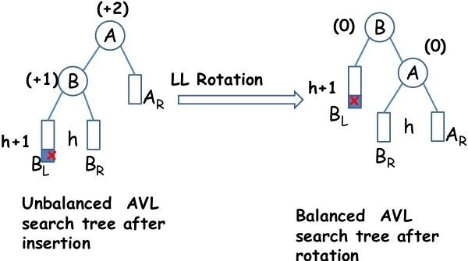
General Notation:

Example:

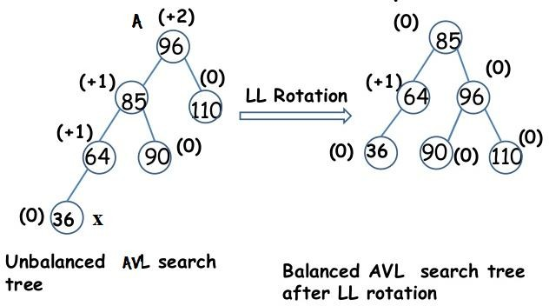

RR Rotation (Single Left Rotation)
- The new node ‘x’ is inserted in the Right sub tree of right child of node A. As a result, the balance of A becomes -2.
- To restore balance at A Single left rotation need to be applied at A.

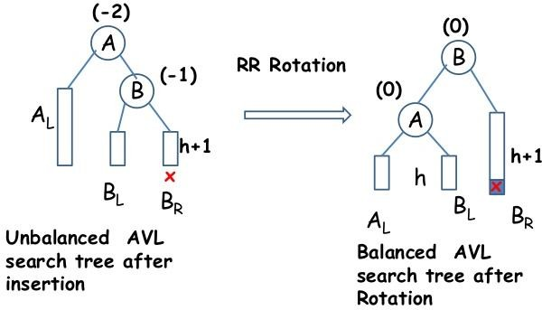
General Notation:

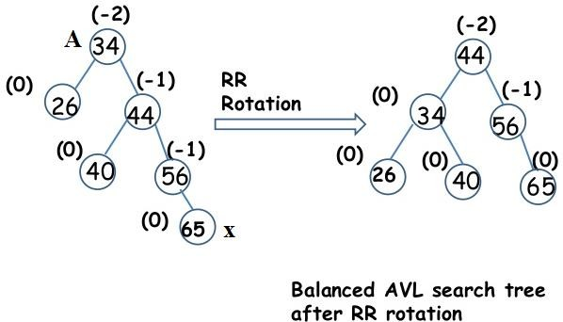
Example:

LR Rotation (Left Right Rotation)
Imbalance occurred at A due to the insertion of node x in the right sub tree of left child of node A.
- LR rotation involves sequence of two rotations
- Single Left rotation/RR rotation
- Single Right rotation/LL rotation

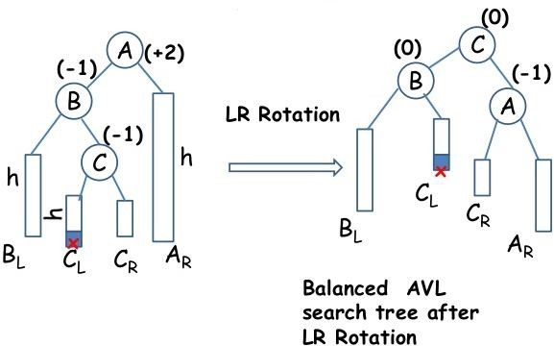
General Notation:

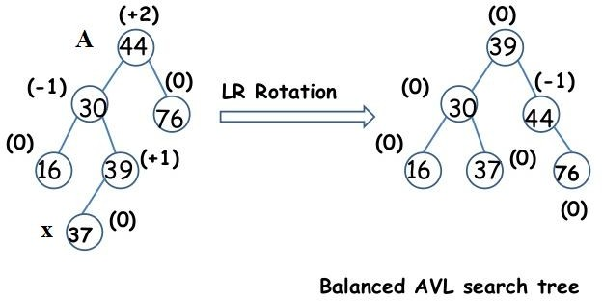
Example:

RL Rotation (Right Left Rotation)
Imbalance occurred at A due to the insertion of node x in the Left sub tree of right child of node A.
- RL rotation involves sequence of two rotations
- Single Right rotation/LL rotation
- Single Left rotation/RR rotation

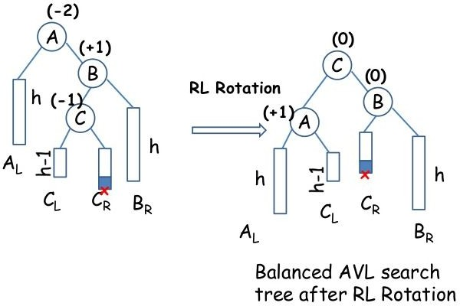
General Notation:

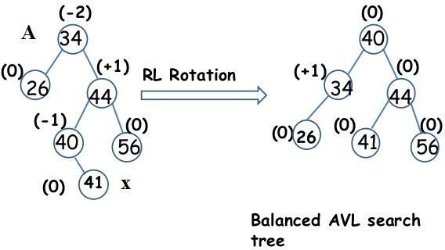
Example:

